OXFORD MODEL FLYING CLUB (OMFC) – 2022 MEMBERSHIP CARD AND QUICK-REFERENCE DOCUMENTATION

Please find attached your 2022 OMFC Membership ‘Card’. For the present it is available in electronic
format only – ie similar to the BMFA Membership Card on the Insurance Certificate) or, if preferred,
it is designed to be cut out, folded and retained.

When flying at Port Meadow, you are strongly advised to have the following documents readily available
in either paper or electronic format:

1. Your BMFA and OMFC Membership Cards.

2. Your BMFA Insurance Certificate.

3. If you are flying a model with a mass of 250g or more, one of the following documents:

a. Your valid CAA Competency Certificate OR

b. Your valid BMFA Recognised Competency Certificate OR

c. Your valid* BMFA RC Achievement Scheme Certificate

* ‘Valid’ means:
(i) Obtained before 31/12/2020 on an outdoor model type
(ii) You have declared that you have read and understood the terms of the BMFA Article 16 Authorisation

Note: to remain up-to-date with regulatory changes, all OMFC flyers are advised to take the BMFA RCC Test
regardless of their BMFA Achievement Scheme status.

Additionally, you are advised to store the following contact numbers in your mobile phone in case of a
‘flyaway’ model:

1. Air Traffic Control at London Oxford Airport (Kidlington) 01865 290650

2. Air Traffic Control at RAF Brize Norton 01993 897785

3. Network Rail Oxford Work Station: 01865 245539

Your Club Membership Card Here

PORT MEADOW – LOCAL FLIGHT RESTRICTION ZONES (FRZs) AND CONTROLLED AIRSPACE
Important: models must not enter an FRZ without permission from the relevant ATC authority. If there is a chance that a fly-away model might enter an FRZ, the relevant ATC unit must be informed at the earliest safe opportunity. If in doubt…make the call. All flyaways must be reported to the CAA iaw the BMFA’s Article 16 Authorisation.
FRZs
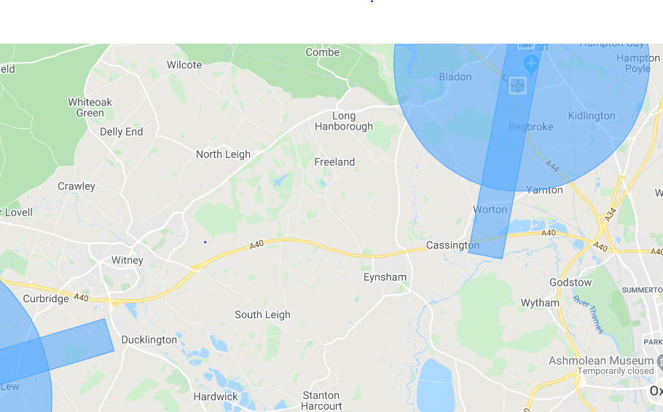
Brize Norton FRZ
01993 897785 (ATC)
01993 897728 (ATC)
01993 897554 (Ops)
Port Meadow
Oxford Airport FRZ
01865 290650 (Tower)
01865 844272 (ATC)
01865 841807 (Ops)
2m N

Brize Norton Control Zone (CTZ) (shown in red)
Oxford Airport FRZ
Note – Oxford Airport FRZ is also shown for reference
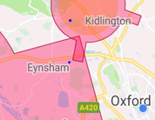
Port Meadow
Brize Norton Control Zone (Ground level to 3500ft)
In event of flyaway that might enter the Brize CTZ, it is not mandatory to call Brize ATC; however, you are advised to do so due to the possibility of entering the Brize FRZ

4km N

OMFC FLYING FIELD REFERENCE CARD V2 14 June 2021 - INTENDED FOR FIELD GUIDANCE ONLY; ALWAYS REFER TO OFFICIAL DOCUMENTS

Operator Responsibilities | Remote Pilot Responsibilities
- Pilot meets competence requirement  - Model is in safe condition to fly  - Pilot aware of limitations and conditions of authorisation  - Pilot aware of rules and procedures  - Pilot is has appropriate authorisations and permissions  - Pilot is aware of airspace limitations  If operating under Article 16 you must be:  - Registered with the CAA*  - Display Operator ID on or in aircraft*  - A BMFA member (or other approved organisation)  (BMFA Mandatory Question 18 ‘Three Requirements’)  *Not required for models weighing less that 250g and flown below 400’ | You must:  - Carry evidence of competence  - Comply with BMFA and Club rules  - Be familiar with operating instructions  Before Flying (BMFA Mandatory Question 6 ‘Four Things to check’):  - Ensure weather and operating environment is suitable  - Check that you are fit to fly  - Check airspace restrictions (inform other agencies if required)  - Ensure that your model is safe to fly  During Flight Pt 1 (BMFA Mandatory Question 13 ‘Two Conditions’):  - Comply with Article 16  - Comply with any airspace restrictions  During Flight Pt2 (BMFA Mandatory Question14 ‘Always Avoid….’ points)  - Avoid risk of collision with manned aircraft.  - Do not fly in or close to any emergency response effort without permission  - Do not endanger aircraft, people, animals, environment or property

1. Documentation (Paper or Electronic) | 2. Flying Site Checks (SWEETS)
- BMFA Membership/Insurance  - Contact details of local air traffic control (Kidlington and Brize)  - Contact details of Railway Company  - If operating a model weighing 250g or more:  CAA Operator ID correctly displayed and either: CAA Flyer  ID, BMFA RCC or valid RC Achievement Scheme certificate | - Sun position  - Wind direction, strength and turbulence  - Eventualities (at Meadow consider: people; dogs; livestock; full-  size aircraft - especially police/air ambulance helicopters)  - Emergencies (consider available emergency landing areas)  - Transmitter control (if using 35 MHz)  - Site rules pertaining to model type
3. Model Checks | 4. RC Pre-flight Checks
- Airframe: check for damage; demountable parts secure  - Servos secure  - Linkages and Surfaces (secure at servo; check clevis, horns, hinges)  - Undercarriage aligned and secure  - Propeller undamaged and secure  - Aerial undamaged and correctly orientated  - Batteries (TX and RX/flight) correct, charged and secure. | - Frequency check (35 MHz)  - Switch on TX and model in correct order  - Range check  - Failsafe check  - Control check (correct sense, full and free, servo response)*  *If applicable, carry out under full power
5. RC Pre-launch Transmitter Checks (SMART) | 6. Post-flight Checks
- Switch on  - Model (correct selection) and/or Meter in the ‘Green’  - Aerial secure cand extended  - Rate switches in correct position  - Transmitter voltage and Trims | - Receiver and Transmitter off  - Clear frequency control (35 MHz)  - Clean your model  - Check propeller, airframe, undercarriage

Additional Flying Site Checks for Free-flight | Additional Pre-launch Checks for Free-flight
- Assess flight path considering likely aircraft performance,  weather and flight termination device  - Be ‘reasonably satisfied’ that flight path will not enter FRZ or  other restricted airspace  - Operate within Article 16 (or Open Category)  - Do not fly beyond Visual Line-of-Sight | - Check area is free from ‘uninvolved persons’  - Identify the anticipated ‘flight volume’  - Only launch when reasonably satisfied that aircraft will remain  inside the ‘flight volume’  - Only launch when reasonably satisfied that no uninvolved  Persons will enter the flight volume and be endangered

Maximum Height | Normally 400ft above the Earth’s surface. You may fly above 400ft provided the model:  - Is not a multi-rotor (no more than ‘one lifting propeller’)  - Is not automated/autonomous  - Is not operating in an FRZ (unless permission has been obtained)  - Remains within unaided visual line-of sight  - Weighs 7.5kg or less at take-off (note: gliders weighing less than 14kg  may fly up to 400ft above the remote pilot Note - mainly intended for slope soaring)  Important Note: For models weighing less than 250g, CAA registration and pilot competency are required for flight above 400ft
Minimum Distance from Uninvolved Persons*  *Persons not aware of instructions and safety precautions given by UAS Operator | Models weighing less than 250g: No minimum distance  Models weighing 250g – 7.5kg: 30m*  Models weighing 7.5kg – 25kg: 50m  *15m for take-off/landing subject to mitigation and risk assessment
Minimum Distance from Assemblies of People*  *Persons unable to move away due to density of people present | Model weight less than 250g: No minimum distance  Model weight 250g – 7.5kg: 30m horizontal distance (ie do not overfly)  Model weight 7.5kg – 25kg: 50m horizontal distance (ie do not overfly)*  *30m for take-off/landing subject to mitigation and risk assessment
Report to AAIB & CAA (AAIB Tel 01252 512299) | Any accident or serious incident involving fatality or serious injury
Report to CAA | Any occurrence involving (BMFA Mandatory Question 17 ‘Four Circumstances’):  - Manned aircraft  - Operations above 400ft  - Operating within 50m of uninvolved persons  - Instances where aircraft have flown beyond visual line-of-sight  - Display Flying

